**CH 245: ORGANIC CHEMISTRY I LABORATORY (Fall 2019)**

**Title:**

1. **Purpose: (1 point)**

**To analyze the active ingredient in 4 different analgesics, identify an unknown active ingredient in a mixture, compare the effect of a solvent on a calculated Rf value, and to learn about the process of Thin Layer Chromatography.**

1. **Drawing of structure of the main compound or balanced chemical equation if synthesis is performed: (1 point)**

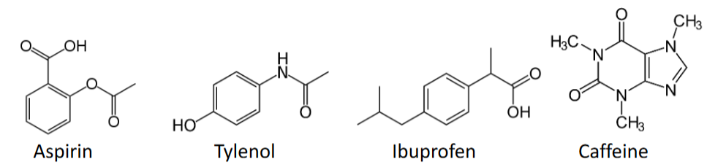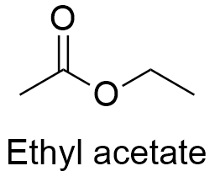

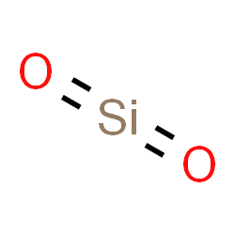 Silica

**3. Reagents and the major product (up to 5 points)**

|  |  |  |  |  |  |  |
| --- | --- | --- | --- | --- | --- | --- |
| **Name** | **M.W.**  (0.5 pts) | **Density**  (0.5 pts) | **Amount (grams/mL)**  (0.5 pts) | **Moles**  (0.5 pts) | **Hazards/Precautions**  **(MSDS data) and melting point or boiling point** (2 pts) | **Role of the reagent\*** (1 pts) |
| Aspirin | 180.158 | 1.4 g/cm3 | N/A | N/A | Harmful if swallowed, causes skin and eye irritation | Reactant |
| Tylenol | 151.163 | 1.29. g/cm3 | N/A | N/A | Slight skin and eye irritant | Reactant |
| Ibuprofen | 206.27 | 1.03 g/cm3 | N/A | N/A | Harmful if swallowed, causes serious eye irritation | Reactant |
| Caffeine | 194.096 | 1.23 g/cm3 | N/A | N/A | Toxic if swallowed | Reactant |
| Ethyl Acetate | 88.11 | 0.902 g/cm3 | N/A | N/A | Highly flammable, causes serious eye irritation | Solvent |
| Hexane | 86.18 | 0.659 g/cm3 | N/A | N/A | Highly flammable, may be fatal if swallowed, causes serious skin and eye irritation | Solvent |
| Silica | 60.08 | 2.65 g/cm3 | N/A | N/A | Respiratory irritation and skin and eye irritation | N/A |

**For Role of the reagent*, Choose from the following options:**

**Reactant, Product, Solvent, Drying agent, Catalyst**

**4. Calculations: (1 point)**

Show each calculation for moles of reagents and for theoretical and actual yield. Fill in the box with the limiting reagent and theoretical yield:

The limiting reagent is

The theoretical yield is

**5. Procedure (up to 2 points)**

|  |  |
| --- | --- |
| **Procedure** | **Observations and Lab Data** |
| A summary of the procedure done with bullet points) | Color changes, exothermic or endothermic reactions, gas generation, etc.; tare weights for flasks, etc. |
| * Line a TLC bottle with folded filter paper. * Add just enough ethyl acetate to cover the bottom of the bottle by 2-3 mm. Cover bottle and set aside. * Draw two light pencil lines on the TLC plates 1 cm from the bottom and top. Draw lines on coated sides. * Take a small amount of the four knowns in separate labeled beakers and add a small amount of hexane. * Using a capillary tube, spot place small spots on the starting line of the first plate. Do 2-3 substances on each plate. * Develop the chromatogram by placing the treated plates in the chamber, making sure the edges do not touch the sides of the bottle and that the bottom spotting line is above the solvent. * Allow the solvent to rise up the plate by capillary action until the solvent reaches the top line. * Remove the plate from the chamber and allow it to dry for 1-2 minutes. Place next plate in chamber while waiting, and repeat until all substances have been tested. * Bring each developed plate to be viewed under UV radiation. Mark the developed spots with a pencil and measure the Rf values and record. * Continue until clear values are obtained, at least two trials per substance. * Repeat with unknown substance and calculate Rf value of unknowns. * Identify unknown active compound by comparing with known Rf values. * If inconclusive, repeat with 50% ethyl acetate and 50% hexane as developing solvent. * Repeat procedure with aspirin and this new solvent. |  |

**6.** Results; include actual yield in grams and % yield.

**Results (need to get signed by instructor or TA):**

|  |  |  |  |  |  |  |  |
| --- | --- | --- | --- | --- | --- | --- | --- |
|  | **A** | **U** | **B** | **C** | **U** | **D** | **C (hexenes)** |
| **Distance Moved (cm)** | 1.7 | 1.6 | 3.1 | 1.8 | 1.9 | 0.5 | 1.3 |
| **Total Distance (cm)** | 4.0 | 4.0 | 4.0 | 4.5 | 4.5 | 4.5 | 4.0 |
| **Calculated Rf** | 0.425 | 0.4 | 0.775 | 0.4 | 0.42 | 0.11 | 0.325 |
| **Substance** | Tylenol | Unknown | Ibuprofen | Aspirin | Unknown | Caffeine | Aspirin in 50% Hexenes |

**I identified the unknown as aspirin, due to the similar Rf values as well as the similar looking streak on the TLC plates.**

**The measured Rf value when using 50% hexenes is lower compared to using 100% ethyl acetate.**

**Conclusion**

I **accomplished** a TLC analysis of four compounds and an unknown, and identified an unknown using TLC. I also saw the effects of using different solvents in the TLC bottle on the measured Rf value. I **learned** about how we can use TLC analysis to identify compounds, and how the polarity of the mobile solvent changes the Rf value. One **issue** I had during the experiment was that sometimes I placed the TLC plate too close to the wall, and the substances would curve up the plate and get a bad reading. Thus**, in the future**, I will be more careful with the TLC plate and make sure that the plate stays in the middle of the bottle. **The practical application** of this experiment is to be able to use TLC to identify the active compound in unknown compound in industry.

**Post Lab Questions**

The most polar analgesic is Ibuprofen, and the least polar analgesic is caffeine, due to their high and low Rf values respectively.

Toluene has the lowest elution, then acetophenone, then benzoic acid.

You can use other compounds to react with and dye the TLC plate. For example, iodine reacts with aromatics, and phosphomolybdic acid reacts with alkenes, that may color the alkene that does not show under UV light.

I would use ethyl acetate and methanol to increase the Rf because these compounds are more polar and have higher elution strength, so these solvents have a better chance to move the caffeine up the TLC plate due to their higher elution strength.